When researching we found a simple tool for us to use to create the wireframe – wireframepro.com.

As complete beginners when it came to creating wireframes, research was necessary.

We also need to understand how the client and the user will interact with the program, the wireframe will help us to do this and help us change any plans we have.

We knew it would kind of need to be like a ‘blue print’ of what our final design will be like.

When it comes to the design process we chose to sketch > wireframe > code

Sketches below:

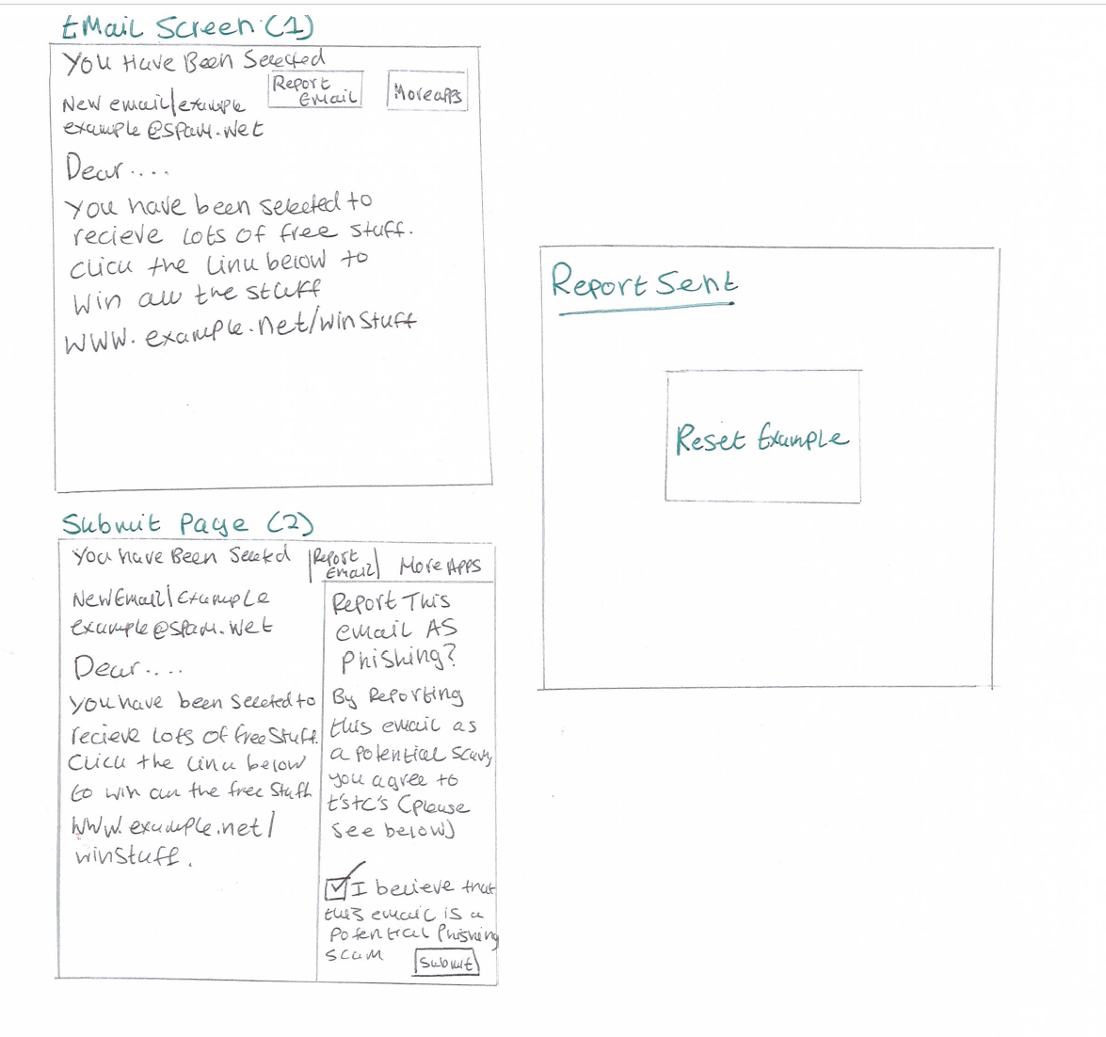

References:

https://webdesign.tutsplus.com/articles/a-beginners-guide-to-wireframing--webdesign-7399